KidzCoding Hour of Code - Code.org Maze Activities

Activity:

In this activity, students will learn how to use code to navigate through digital mazes. This fun interactive activity uses code.org activities to help students learn to navigate a character using directional commands, if statements and loops.

Learning Objectives:

* Understand how to move a character using movement commands
* Understand how to use conditional statements for to navigate characters
* Use loops to make code more efficient

Materials:

* Code.org Classic Maze: <https://studio.code.org/hoc/1>
* Code.org Mine Craft Hero’s Journey: <https://studio.code.org/s/hero/lessons/1/levels/1>

Coding Time!

**Part One Classic Maze**

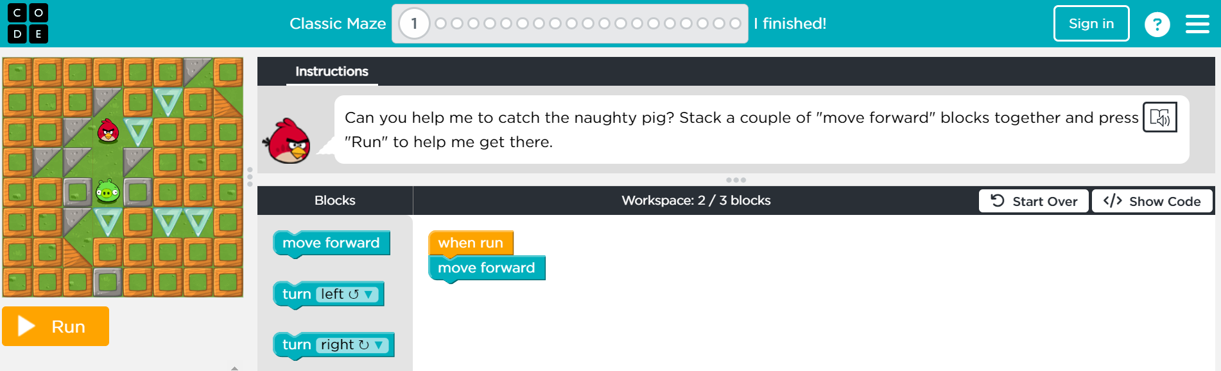

This activity allows for both self-guided and instructed activity. Instructors should allow students to attempt each level on their own, while stepping in and providing guidance when needed. When the maze introduces any new part such as loops or if statements, clearly explain to the students what each new command means and how it can be used in the maze.

**Part Two Minecraft Maze**

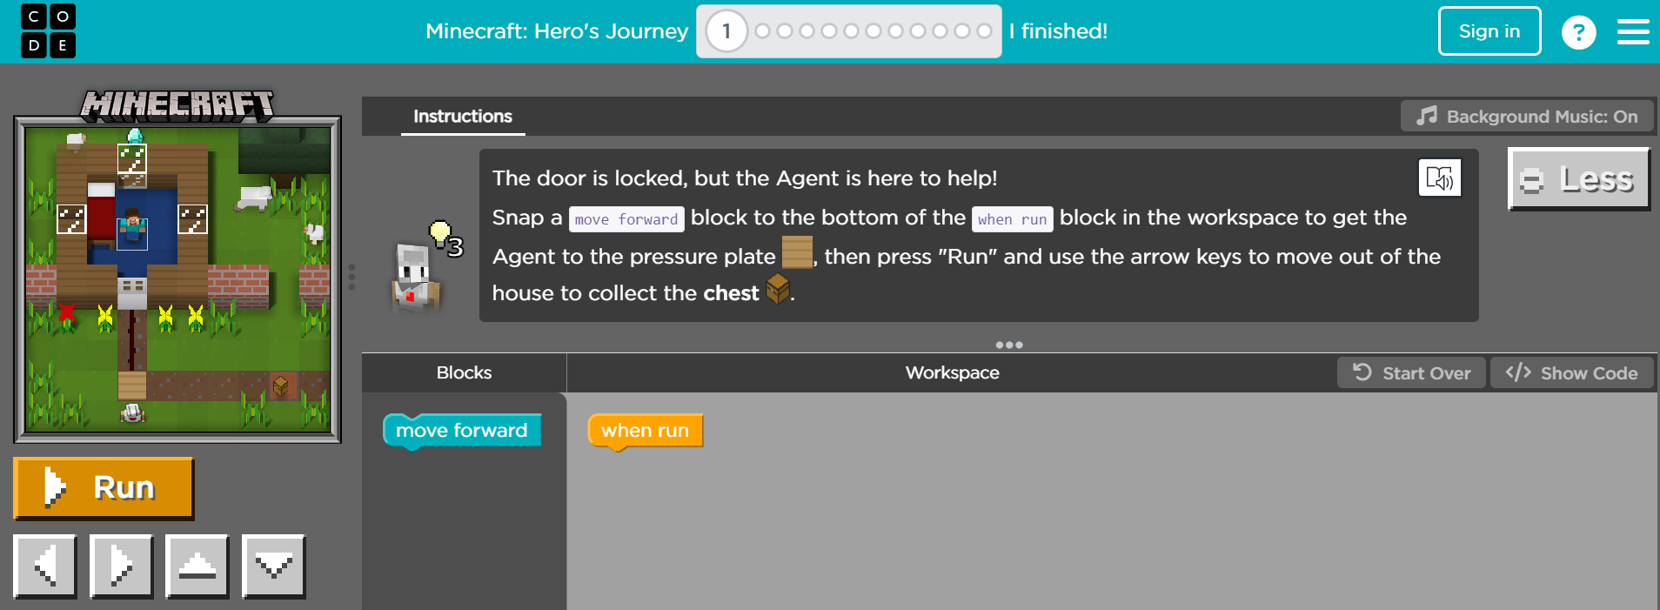

This activity will feel similar to the first one in many ways, allowing for the students to interact with a familiar environment. However, this activity introduces a character that is controlled by user inputs. This will help students get familiar with interacting with a combination of user inputs and assets completely controlled by code. This can be very useful when learning how to make games in programs such as Scratch. See our Scratch guides.

**Congratulations, You Have Just Completed an Hour of Code!**

All code.org activities belong to code.org and are licensed under a Creative Commons Attribution-NonCommercial-NoDerivatives 4.0 Unported License.